Instruction:

Complete all questions in 2 hours.

1. Von Neumann Simulator. This program simulates a very simple computer with the von Neumann architecture.
   1. Download the von Neumann Simulator (VonNeumann.exe) program from google classroom in the Week-7 folder. Save it in your Documents folder and run it. You will see a window similar to this:

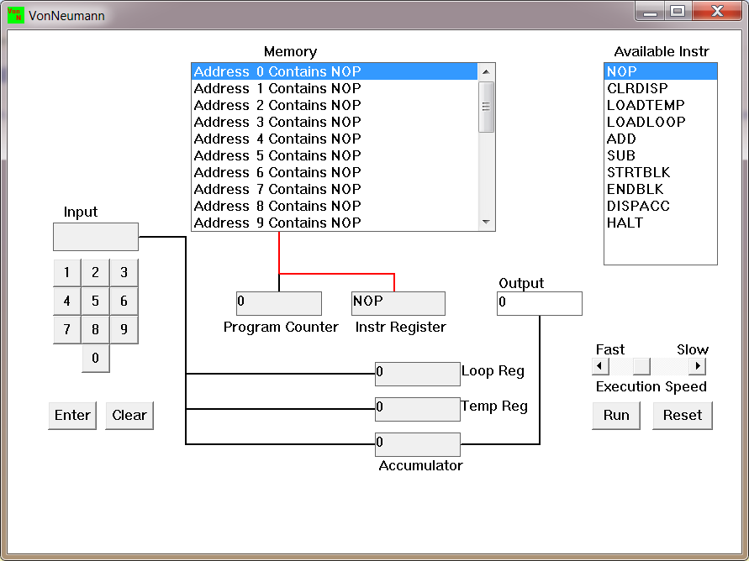

The simulator has a small program memory area which is available for programming. To enter your program instructions simply click on the “Available” instruction on the list on the right and then click on the “Memory” location you wish to put it in.

This simulator understands only the following ten instructions:

|  |  |
| --- | --- |
| NOP | No Operation, i.e. do nothing. |
| LOADTEMP | Get a number from the keypad, completed by the Enter key, into the Temporary Register. |
| LOADLOOP | Get a number from the keypad, completed by the Enter key, into the Loop Register. |
| CLRDISP | Clear the Display. |
| ADD | Add the Temporary Register to the Accumulator |
| SUB | Subtract the Temporary Register from the Accumulator |
| DISPACC | Display the contents of the Accumulator |
| STRTBLK | Start of Loop Block |
| ENDBLK | End of Loop Block |
| HALT | Halt. Stop Program |

1. Load the following program in the memory and explain what does the program does?

LOADTEMP

ADD

LOADTEMP

ADD

DISPAAC

HALT

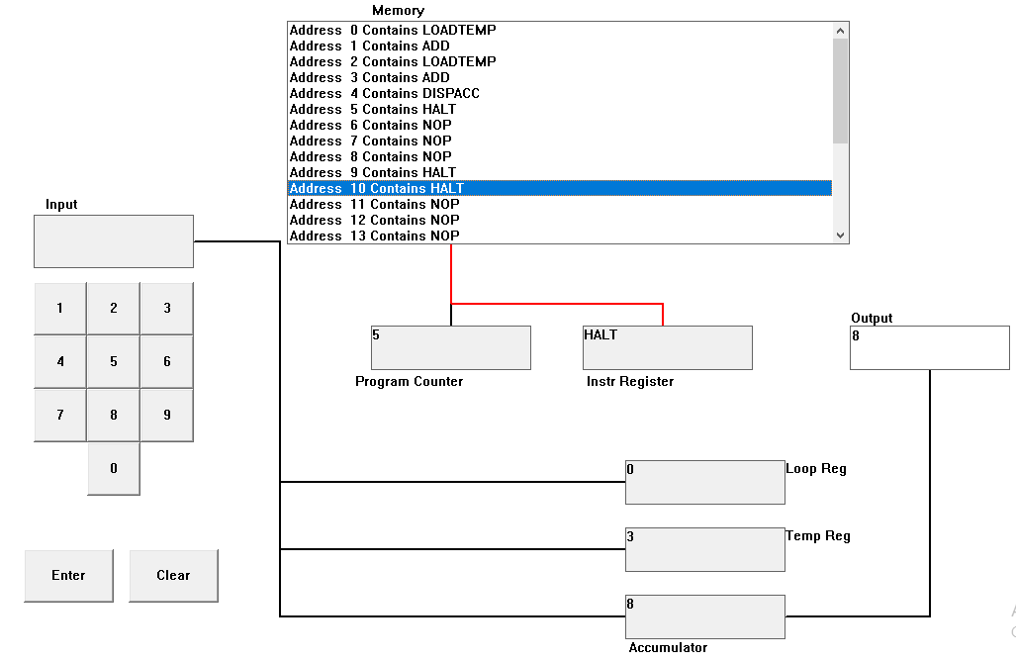

In the above program two numbers are added i.e., 10 and 20. Firstly, instructions LOADTEMP, ADD, LOADTEMP, ADD, DISPAC AND HALT is loaded to the memory respectively. Then, the input is taken as 10 from LOADTEMP in address 0 which is placed in Temp Reg (Temporary Register). The number is then added with 0 due to ADD instruction in address 1. Again, the LOADTEMP in address 3 is activated which prompts the user for the input. The input two is taken as 20. The ADD instruction in address 3 adds the input one and input two GIVING THE RESUSLT 30. The added value is then stored in accumulator. Finally, DISPACC sends the data to the output and the program ends after HALT instruction.

1. Write the program to add three numbers together and explain how does your code works?

*Ans:*

LOADTEMP

ADD

LOADTEMP

ADD

LOADTEMP

ADD

DISPACC

HALT

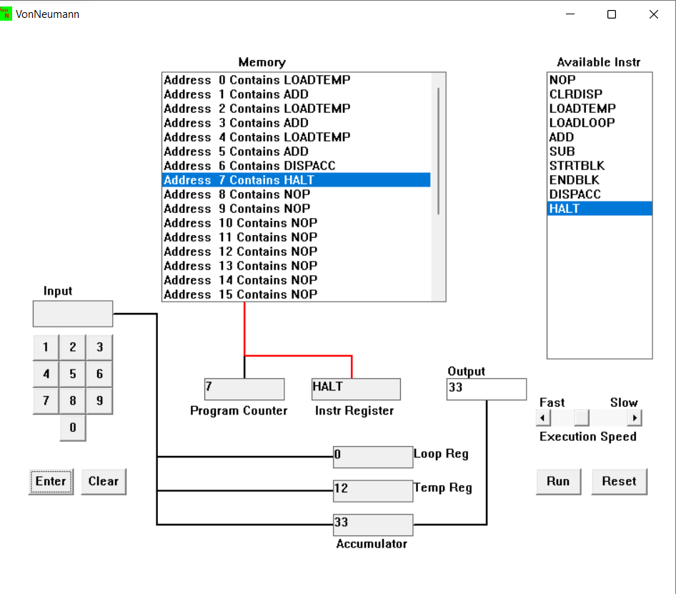

In the above Von Neumann Simulator, three numbers i.e., 10, 11, and 12 are added. This is done using LOADTEMP, ADD, DISPACC and HALT instructions in the memory. Firstly, we use LOADTEMP in address 0 to input our first number i.e. 10 in the temporary register. The number is then added with 0 due to ADD instruction in Address 1. This process is again repeated and we input 11 in the LOADTEMP in Address 2, which is then added with 10 using ADD instruction in Address 3. This operation results with 21 in temporary register. We again repeat these instructions with LOADTEMP in Address 4 and ADD in Address 5 which adds our final input 12 with the output 21. Finally, the output 33 is shown using DISPACC in Address 6 and the program ends after HALT instruction in Address 6.

1. Write the program to perform

 7+3-9

LOADTEMP

ADD

LOADTEMP

ADD

LOADTEMP

SUB

DISPACC

HALT

-9+3-7

LOADTEMP

ADD

LOADTEMP

SUB

LOADTEMP

SUB

DISPACC

HALT

13-7+19

LOADTEMP

ADD

LOADTEMP

ADD

LOADTEMP

SUB

DISPACC

HALT

1. Write a program to perform

7+(7*3)

LOADLOOP

LOADTEMP

STRTBLK

ADD

ENDBLK

LOADTEMP

ADD

DISPACC

HALT

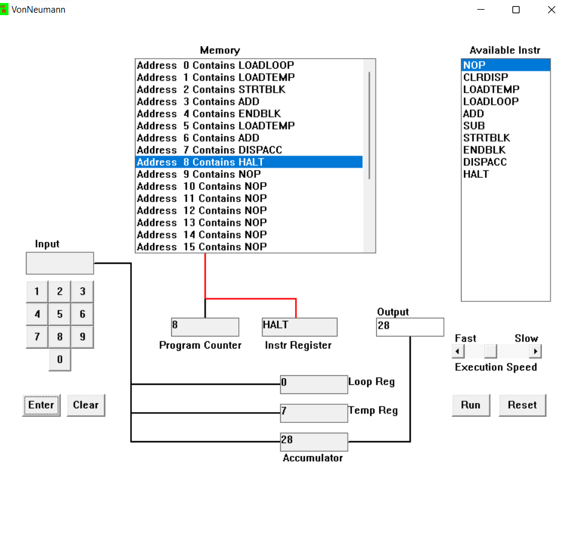

3+(3*7)

*ANS:*

LOADLOOP

LOADTEMP

STRTBLK

ADD

ENDBLK

LOADTEMP

ADD

DISPACC

HALT

1. Write a program to add first 10 natural numbers.

LOADLOOP

STRTBLK

LOADTEMP

ADD

ENDBLK

DISPACC

HALT

